September 2007

Due to the Foot and Mouth restrictions we are now offering a “farm to farm” sale service and have the following stock available to prospective purchasers:-

A Good Selection of Blue Faced Leicester Ram Lambs Available

Rams available are sired by: Bonvilston, Myfyrian & Teviot

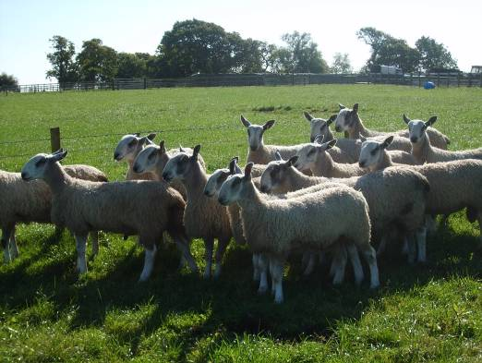

30 Blue Faced Leicester Yearling Rams Available

Rams available are sired by: Bonvilston, Carry House, Barlaes & Myfyrian

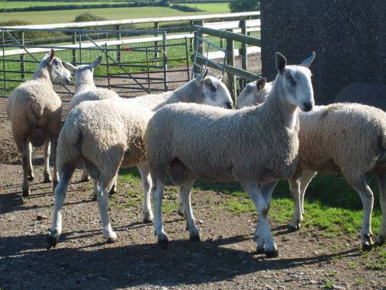

A Good Selection of Crossing Ram Lambs Available

Rams available are sired by: Ty-Mawr

10 Crossing Yearling Rams Available

Rams available are sired by: Ty-Mawr

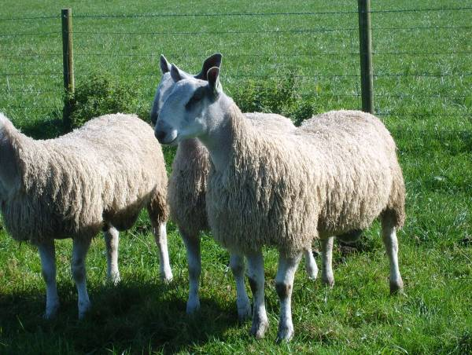

Third Prize winner at the Royal Welsh Show 2007

Please contact us if you require further information on any of our Stock Rams
Viewing of Rams recommended although
please contact us prior to your visit to ensure stock availability.

